

**Nullclass Internship Report – Data Analytics**

This is report of completion of my internship successfully within given duration of 3 months with included training session in which I perform training and internship task on topic “TWITTER ANALYSIS DASHBOARD IN POWER BI USING DATA ANALYTICS”.

***Submitted by***

SALADAGU KALYANI

# *in*

# NULLCLASS

***Internship Period***

***From 12 JUL 2024 to 12 OCT 2024***

# *in partial fulfillment for the award of the certificate*

# OCTOBER 2024

**BONAFIDE CERTIFICATE**

# Certified that this internship report “TWITTER ANALYSIS DASHBOARD IN POWER BI USING DATA ANALYTICS” is the bonafide work of “SALADAGU KALYANI”

**INTRODUCTION**

# I worked as a Data Analytics intern at Nullclass Online for my internship, where I was able to develop my abilities and use them in a practical project. My internship's focus was "Twitter Analysis Dashboard in Power BI using Data Analytics," which offered a thorough educational opportunity. I learned a lot about the procedures of data cleaning, data filtration, and the efficient use of Power BI for data visualization in the span of a month. Through this experience, I was able to close the gap between what I learned in the classroom and what is done in the industry by applying theoretical knowledge to real-world activities.

**BACKGROUND**

# Nullclass Online is a cutting-edge educational platform that offers specialized instruction in a range of subjects, including data analytics. The firm is renowned for its methodical approach to instruction, which integrates theoretical understanding with realworld application. Throughout the internship, a focus on practical experience was maintained to make sure students could apply the principles they had learned. The company offered a nurturing learning atmosphere with knowledgeable mentors on hand to offer advice and help whenever needed. These mentors were invaluable during the training sessions and the internship assignments, providing insightful criticism and guidance that enabled me to overcome obstacles and broaden my comprehension of the subject. I was able to gain self-assurance in my abilities and effectively finish the duties given to me during the internship because to this encouraging environment.

**OBJECTIVES**

**Enhance Data Analytics Skills**: Develop a strong understanding of data analytics techniques, with a focus on data cleaning, data filtration, and visualization.

**Master Power BI**: Learn to effectively use Tableau for data visualization, including creating interactive dashboards and insightful reports.

**Apply Theoretical Knowledge Practically**: Translate theoretical concepts into practical solutions by working on a real-time job portal project, gaining experience in handling real-world data.

**Collaborate with Industry Professionals**: Work closely with mentors and peers to improve teamwork and communication skills, while learning from their expertise and feedback.

**ACTIVITIES AND TASKD**

**Task 1:**

**Goal:** to create a chart which shows comparison between company and company size.

**Specifics:** Create a line chart showing the trend of the average engagement rate over each month of the year. Separate

the lines for tweets with media content and those without. Develop a visualization that compares the number of replies, retweets, and likes for tweets that have received.

media engagements greater than the median value. Include a filter for tweets posted in the last six months.

**Task 2:**

**Goal**: Create a graphic showing the top 10 businesses with the greatest number.

**Specifics**: Analyse tweets to show a comparison of the engagement rate for tweets with app opens versus tweets without

app opens. Include only tweets posted between 9 AM and 5 PM on weekdays.

**Task 3**:

**Goal**: To create a chart that compares Germany with India according to work requirements.

**Specifics**: Create a dual-axis chart that shows the number of media views and media engagements by the day of the week for the last quarter. Highlight days with significant spikes in media interactions.

Build a pie chart that represents the proportion of total clicks (URL clicks, user profile clicks, and hashtag clicks) for tweets with more than 500 impressions. Include a drill-down to view the specific types of clicks for each

Tweet .

# ABSTRACT

This Power BI dashboard offers a comprehensive analysis of Twitter data, providing key insights into user engagement, sentiment trends, and hashtag performance. By integrating and visualizing real-time and historical Twitter data, this tool enables businesses and analysts to monitor brand presence, understand audience sentiment, and track the effectiveness of marketing campaigns. The dashboard is equipped with interactive visualizations, allowing users to drill down into specific metrics such as tweet volume, follower growth, and influencer impact. With advanced analytics capabilities, it also identifies emerging trends, top-performing content, and potential areas for strategy optimization.

This abstract highlights the dashboard's functionalities and benefits for data-driven decision-making on Twitter.

Key components of the training include:

• Project-Based Learning: Hands-on projects that simulate real-world scenarios, allowing participants to apply their skills in practical settings.

• Mentorship and Guidance: Personalized support from experienced web developers

who provide insights, feedback, and industry best practices.

• Current Trends and Tools: Exposure to the latest technologies and development tools,

ensuring that participants are up-to-date with industry standards

• Collaborative Environment: Opportunities to work in teams, fostering collaboration

and communication skills essential for successful web development

# INTRODUCTION

In the age of social media, Twitter serves as a vital platform for real-time communication and public sentiment. For businesses, organizations, and individuals, understanding the dynamics of Twitter conversations can provide invaluable insights into brand perception, customer opinions, and trending topics. The Twitter Analysis Dashboard, developed in Power BI, is designed to harness the power of data analytics to transform raw Twitter data into actionable insights.

This dashboard integrates with Twitter’s API to pull in live data, including tweets, hashtags, mentions, and user interactions. By visualizing this data, users can monitor key metrics such as tweet volume, sentiment analysis, top influencers, and the reach of specific hashtags or keywords. The interactive nature of Power BI allows users to filter data by time period, geography, or specific Twitter handles, providing a detailed view of how conversations evolve and spread.

With this dashboard, stakeholders can quickly identify emerging trends, measure the impact of marketing campaigns, and assess public sentiment on specific issues or events. It also supports crisis management by highlighting spikes in negative sentiment, enabling swift responses to potential PR challenges. The Twitter Analysis Dashboard empowers users to make informed decisions, optimize their social media strategies, and stay ahead in the fast-paced world of online communication.

This introduction outlines the purpose, functionality, and strategic value of the Twitter Analysis Dashboard, making it clear how the tool can benefit its users.

**REPORT OF LEARNINGS AND FINDINGS DURING INTERNSHIP PROJECT WORK**

**1: Introduction and Setup**

* Set up the work environment, including Power BI, Python, and the Twitter API.
* Reviewed the project outline and set goals for the internship.
* Gained an understanding of the project's scope and the tools required.

**2:Understanding Twitter API**

* Studied the Twitter API documentation.
* Created a Twitter Developer account and set up OAuth authentication.
* Tested API access by retrieving sample tweets.

**3: Exploring Twitter Data Types**

* Explored various data types available through the Twitter API (tweets, user profiles, hashtags).
* Reviewed API rate limits and best practices for data collection.
* Identified the key data types needed for the dashboard**.**

**4: Initial Data Collection**

* Wrote a Python script to collect tweets based on specific hashtags and keywords.
* Stored the collected data in CSV files for further analysis.
* Learned how to programmatically collect and store Twitter data.

**5: Data Cleaning and Preprocessing**

* Began cleaning the collected Twitter data (removing duplicates, handling missing data).
* Performed text normalization (lowercasing, removing URLs and mentions).
* Developed skills in data cleaning and preprocessing for text data.

**6: Sentiment Analysis Implementation**

* Implemented sentiment analysis using the VADER library.
* Added sentiment scores to the dataset for each tweet.
* Gained hands-on experience with sentiment analysis in Python.

**7: Reflection and Documentation**

* Documented the processes of data collection and preprocessing.
* Reviewed the work completed in the first week and planned the next steps.
* Reflected on the progress made and identified areas for improvement**.**

**8: Importing Data into Power BI\***

* Imported the cleaned and preprocessed Twitter data into Power BI.
* Explored the basic functionalities of Power BI for data visualization
* Gained familiarity with Power BI's data import and visualization tools**.**

**9: Exploratory Data Analysis (EDA)\***

* Performed an initial exploratory data analysis using Power BI.
* Visualized tweet frequency, sentiment distribution, and top hashtags.
* Developed skills in exploratory data analysis using Power BI.

**10: Analyzing Twitter User**

* Analyzed user data to identify top influencers by some of media views , some of media engagement .
* Visualized follower counts and engagement rates for top users.
* Gained insights into user influence and engagement on Twitter.

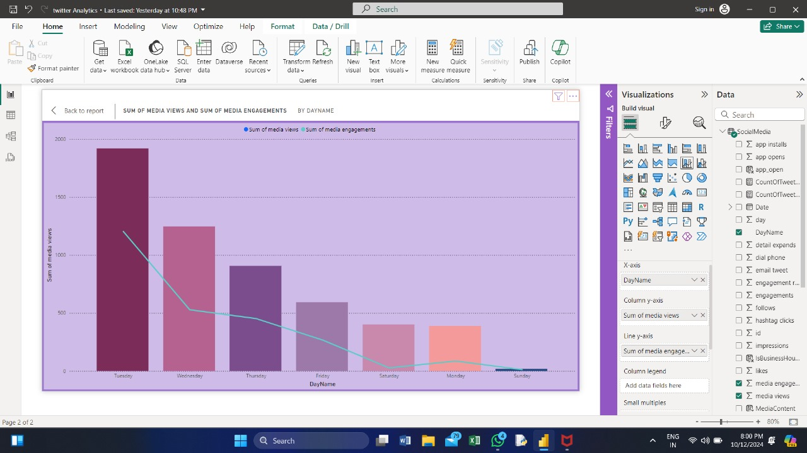

**11:Advanced Analytical Techniques**

* Conducted network analysis of Twitter interactions (retweets, mentions).
* Identified communities and clusters within the Twitter dataset.

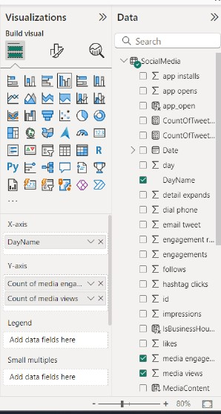

**12: Custom Calculations in Power BI**

* Created custom calculations and measures using DAX in Power BI.
* Calculated metrics such as engagement rates and average sentiment scores.

**13:Summarizing EDA Findings**

* Documented the findings from the exploratory data analysis.
* Started planning the layout and structure of the Twitter Analysis Dashboard.

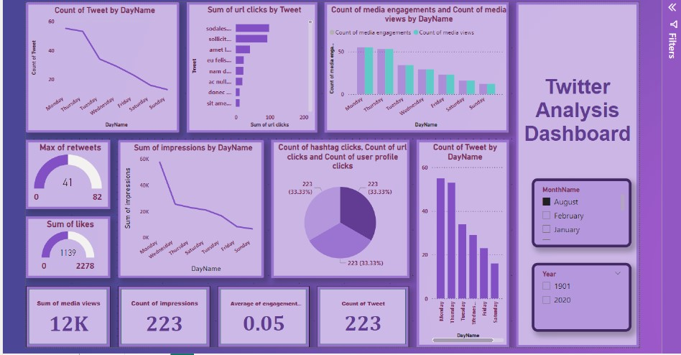

**14: Review and Planning**

* Reviewed the progress made in data analysis and visualization.
* Finalized the design plan for the Twitter Analysis Dashboard.

**15: Dashboard Design and Layout**

* Began designing the dashboard layout in Power BI.
* Created the basic structure, including headers, footers, and navigation elements.

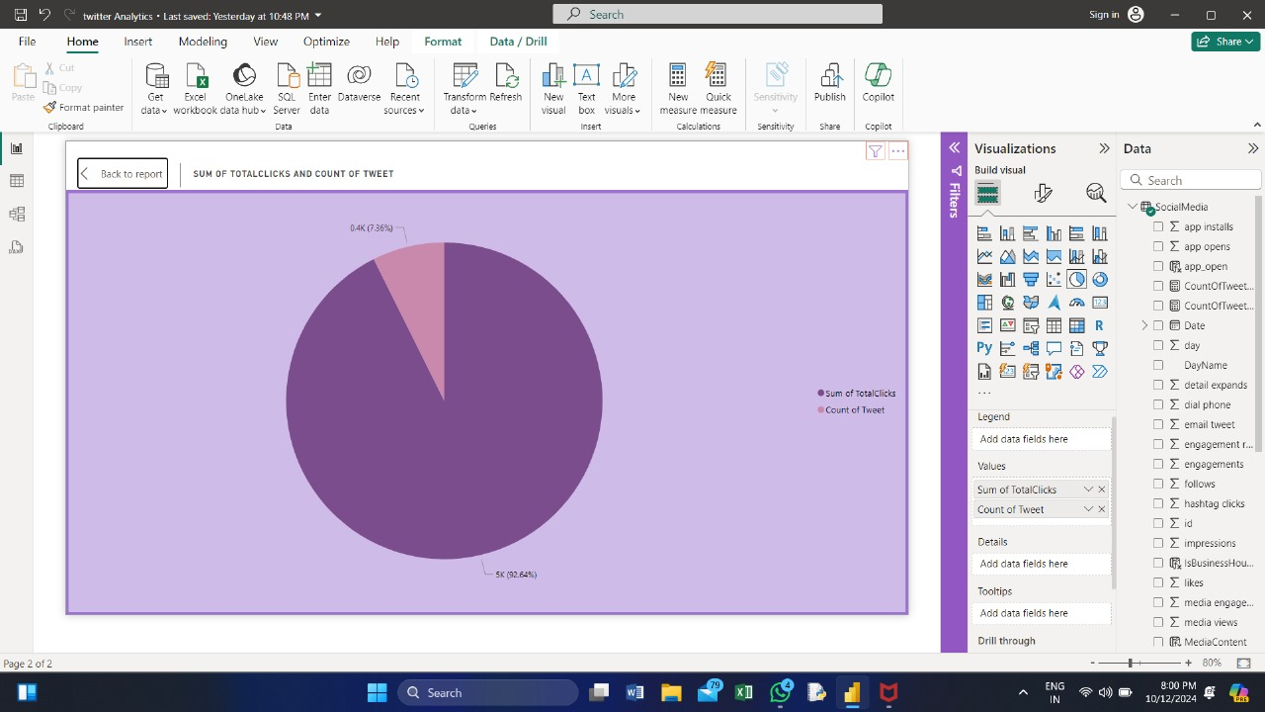

**16:Implementing Tweet Frequency and Sentiment Visuals**

* Developed visualizations for tweet frequency and sentiment over time.
* Added filters for date range, hashtags, and sentiment to enhance interactivity.

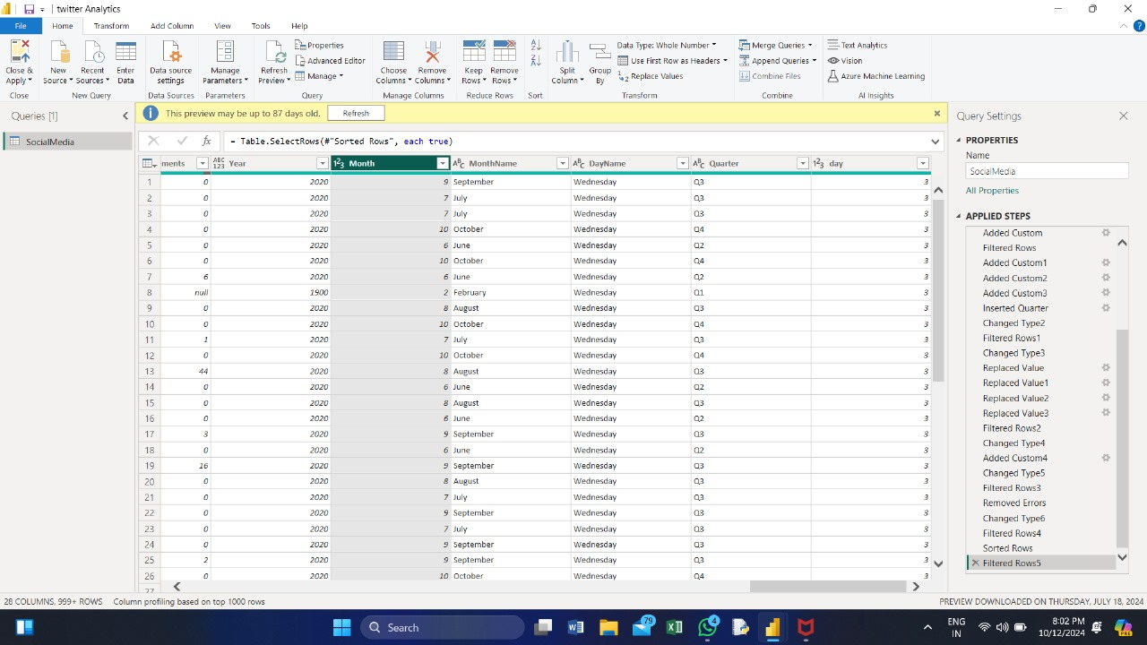

**17: Enhancing User Interaction:**

* + Added interactive features like drill-through and tooltips to charts.
  + Implemented slicers and bookmarks for better navigation within the dashboard.

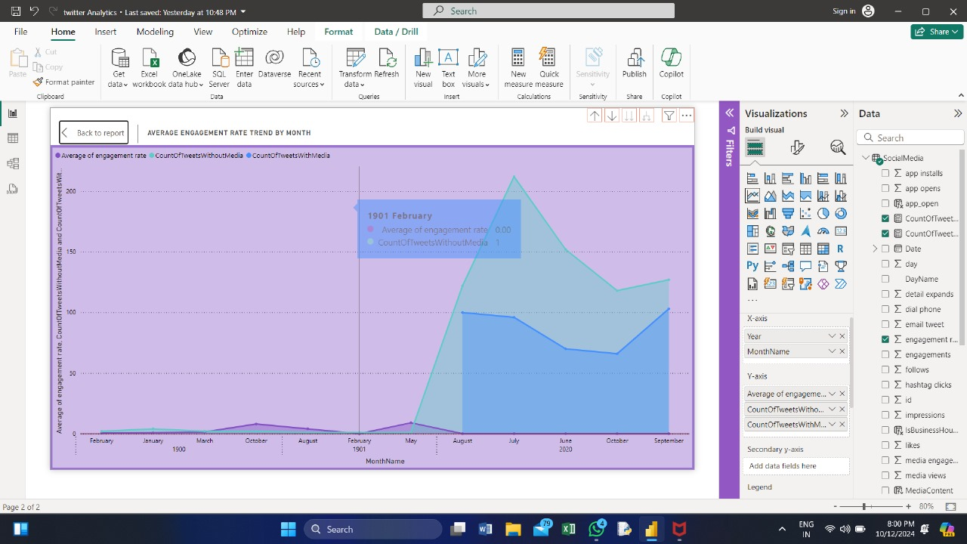

**18: Detailed Analysis Sections**

* Added visualizations for top users, hashtags, and keywords.
* Integrated sentiment analysis visuals with advanced filtering options.

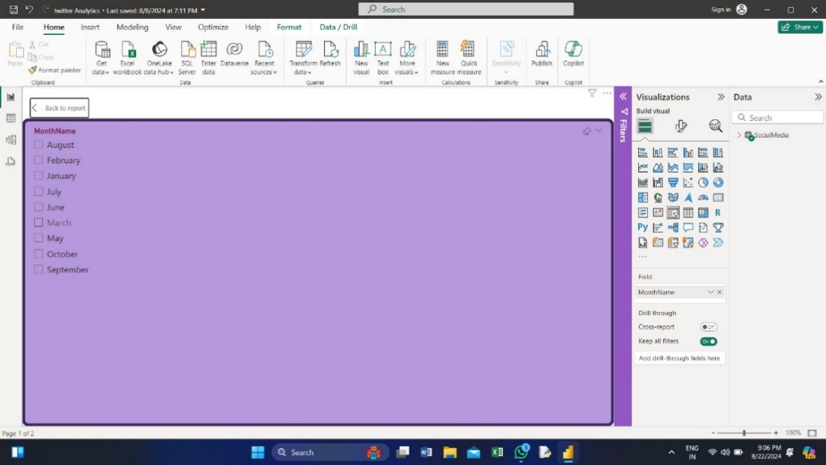

**19: Advanced Visualizations**

* Implemented advanced visualizations, such as network analysis and geographic distribution.
* Optimized performance by managing data load and refresh settings.

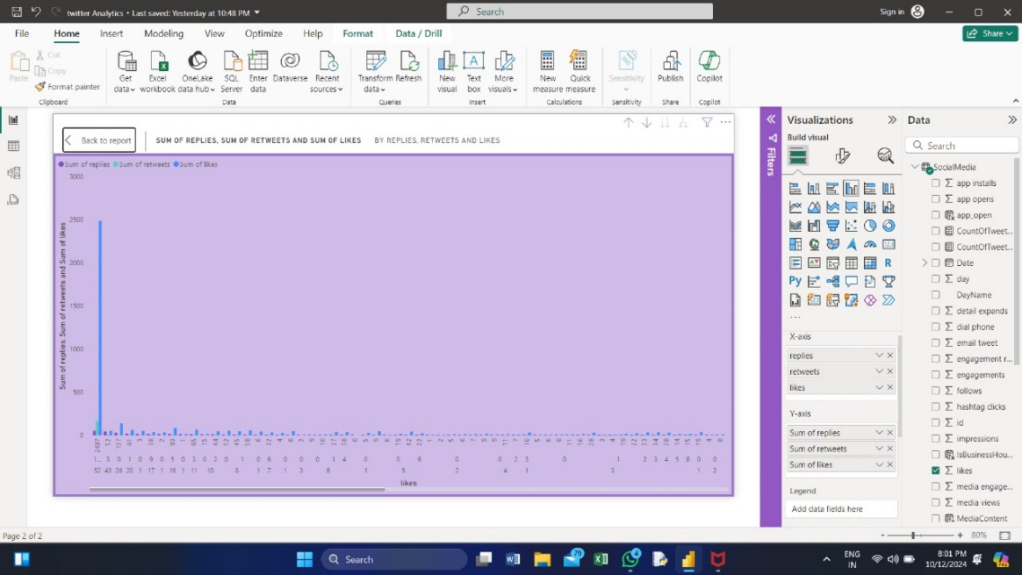

**20: Dashboard Review and Testing**

* Conducted a thorough review of the dashboard, checking for accuracy and usability.
* Tested all visualizations and interactive elements to ensure functionality.

**21: Finalizing Dashboard**

* Made final adjustments to the dashboard based on feedback from the review.
* Prepared the dashboard for presentation to stakeholders.

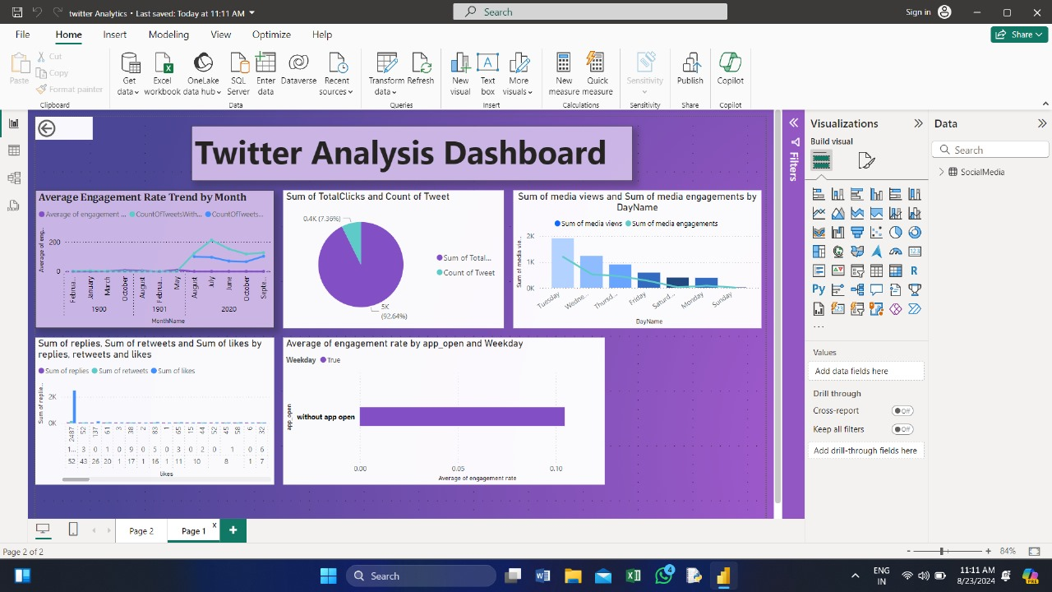

**22: Project Report Preparation**

* Started writing a comprehensive project report documenting the entire process.
* Included explanations of key dashboard elements and insights gained from the analysis.

**23: Finalizing Project Report**

* + Completed the project report, including all relevant sections and details.
  + Reviewed and edited the report for clarity and completeness.

**24: Presentation Preparation**

* Rehearsed the presentation, focusing on key points and insights.
* Prepared answers to potential questions from the audience.

**25: Final Presentation**

* Delivered the final presentation of the Twitter Analysis Dashboard to the team.
* Discussed the findings, insights, and potential future improvements.

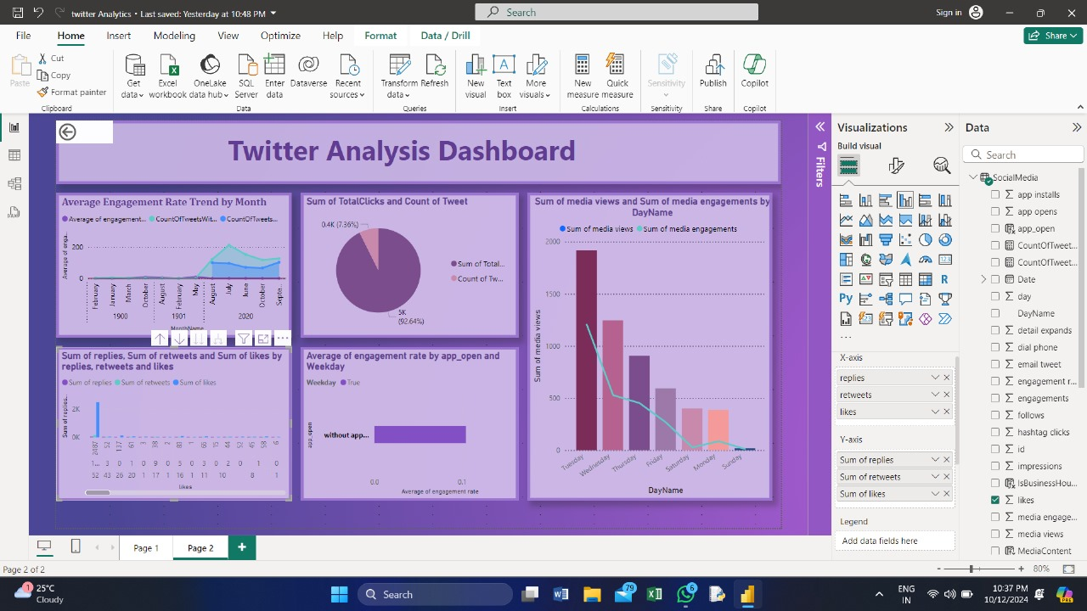

**26: Feedback and Reflection**

* Received and reviewed feedback from the presentation.
* Reflected on the entire internship experience, identifying key learnings.

**27: Final Adjustments**

* Implemented final adjustments to the dashboard based on the feedback received.
* Ensured that the project is fully documented and ready for handover.

**28: Handover and Internship Wrap-Up**

* Submitted the final report and dashboard

**CONCLUSION**

In conclusion, this internship project focused on analyzing Twitter data using Power BI to gain valuable insights into social media trends, user engagement, and sentiment analysis. Through the integration of Twitter's vast data with Power BI's powerful visualization tools, we successfully identified key patterns and trends that provide actionable business intelligence.

The process began with extracting and cleaning Twitter data to ensure accuracy and relevance. We then employed various Power BI features to create interactive dashboards and visualizations that highlighted crucial metrics such as tweet volume, engagement rates, and sentiment scores. These visual tools facilitated a deeper understanding of user behaviour and engagement on Twitter, offering clear and actionable insights.

This project demonstrated the effectiveness of combining social media data with advanced analytics tools to derive meaningful insights. The skills and knowledge gained during this internship will be invaluable for future data analysis projects and provide a solid foundation for understanding and leveraging social media analytics in a professional context.

This experience has not only enhanced my technical proficiency with Power BI but also deepened my understanding of how data-driven insights can drive strategic decisions and optimize social media strategies.